Summary – ODEN Educators Resources

This summary describes resources and tools created to support educators and school staff to consider and reimagine a future that includes employment for students who have a disability. While the resources focus on students with developmental and intellectual disabilities, the themes and lessons offered apply to any student population who has a disability.
Resources were also created for families and caregivers, offering inspiration to work on employability skills at an early age – from JK well into high school. Lastly, practical tools are offered for anyone supporting a youth to discover their desires and strengths when considering employment and career pathways.
If you have any questions, please contact, Ingrid Muschta, Director of Special Projects & Innoavtion at imuschta@odenetwork.com.

Resources and Information:
  - Employment, The Gold Standard of Inclusion Presentation– Train the Trainer This is an interactive workshop that can be delivered either in person or virtually. It is intended to be led by at least one parent or caregiver of a child who has a developmental disability. It can be co-led by another parent or person who has experience working with people who have a disability (for example, an educator, an employment service provider, or a service provider).

    - Presentation Copy Employment The Gold Standard -Train the Trainer-FINAL
    - Employment The GOLD Standard for Inclusion – Workshop Facilitator Guide
    - Hosting a Family Workshop Event – Planning Guide

Raising Expectations: Starting a Pathway to Employment (Early Years)
A self-directed, flexible learning module, Raising Expectations is an opportunity for families and caregivers of a child who has a developmental disability to consider how to support skill building that can prepare them for employment after high school, before they leave the elementary school system. It is about starting a pathway to employment at an early age.
    - To register and access module b, c, d, and e below, in English, use the link: https://learn.odenetwork.com/resources-families-educators/. Please use the instructions in page 3 of this document.
    - ODEN – Family Handbook English
    - Tip Sheet #1: Early-Work-Experiences-Honing-Skills.
    - Tip Sheet #2: Task Planning and Prioritization
    - Tip Sheet #3: Advocate for Inclusion and Employment Awareness

Employment Discovery for Youth who have Disabilities
A self-directed, flexible learning module, Employment Discovery helps young people find out what they like and what they’re good at before they start working. By trying different activities and assessments, you can learn about your strengths and what kinds of jobs might be a good fit for you.
    - Tip Sheet 1: Building Employable Skills at Home and at School
    - Tip Sheet 2: Explore Job Opportunities in Your Community
    - Tip Sheet 3: Essential Resources for Employment Discovery for Youth who have Disabilities
    - Tip Sheet 4: Interview People You Know

Employment The GOLD Standard For Inclusion
A self-directed, flexible learning module, Employment: The GOLD Standard for Inclusion is an opportunity for educators and school staff involved in the education of a child who has a developmental disability to consider how to support skill building that can prepare them for employment after high school.
    - ODEN – Family Handbook English
    - Employment & Inclusion Case Studies
    - Facilitating Supportive Conversations – Creating Safe and Inclusive Spaces for Conversations with Parents/Caregivers
    - Tip Sheet: Strategy Planning and Prioritization for Educators

Disability Awareness & Confidence Training for Educators & School Staff
A self-directed, flexible learning module, Disability Awareness and Confidence Training for Educators and School Staff, an introductory course for educators and school staff who work with students who have developmental and/or intellectual disabilities. It presents an opportunity for educators and school staff to gain a greater understanding of disability and to explore how attitudes and beliefs can create barriers or opportunities for students who have developmental disabilities.
    - Tip Sheet: Disability Awareness & Confidence Training -Resources

To register and access module f, g, h, and i below, in French, use the link: https://learn.odenetwork.com/resources-families-educators/. Please use the instructions in page 3 of this document.

Élever les attentes : entamer un parcours vers l’emploi
    - Inclusion et sensibilisation à l'emploi: Un manuel à l'usage des familles.
    - Feuille de conseils pour les parents et les aidants
    - Tip Sheet 1: Expériences professionnelles précoces et développement des compétences
    - Tip Sheet 2: Organisation et gestion des priorités

Découverte d’emploi pour les jeunes ayant un hándicap
    - Tip Sheet 1: Boîte à outils de découverte d’emploi
    - Tip Sheet 2: Renforcer les compétences d’employabilité à la maison et à l’école
    - Tip Sheet 3: Découvrez les possibilités d’emploi dans votre communauté
    - Tip Sheet 4: Interrogez de personnes de votre entourage

L’emploi : la norme d'excellence en matière d’inclusion
  - Inclusion et sensibilisation à l'emploi: Un manuel à l'usage des familles.
- Études de cas sur l'emploi et l'inclusion
- Faciliter les conversations de soutien
- Tip Sheet: Élaboration de stratégies et gestion des priorités

Sensibilisation et confiance envers le handicap pour le personnel scolaire
  - Tip Sheet: Ressources de formation pour sensibiliser au handicap et renforcer la confiance des éducateurs·trices et du personnel scolaire

Instructions For User Account and Group Code Registration
Steps 1 through 6 explain how to create a user account, use group codes, and access course content.

Step 1- Visit ODEN Learning Centre at https://learn.odenetwork.com/

Step 2- You received a “Group Code” from your Administrator, Team Lead or HR team to access the ODEN’s online course. Be sure to have it available as you navigate the next steps.

On the ODEN Learning Centre home page, click the purple “Register” button located at the top right-hand side of the navigation menu. Note the yellow box and yellow arrow shown in Figure 1.
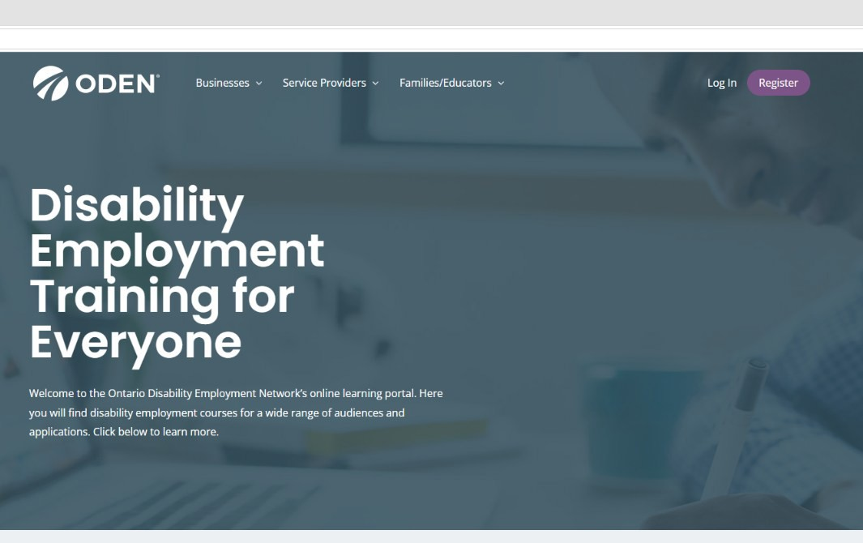
Figure 1. ODEN Online Learning Centre Home Page and location of the “Register” button

Step 3- You will be directed to the User Registration page. Fill in the form shown in Figure 2.

You will be asked to complete the required fields:
- Username
- Email
- First Name
- Last Name
- Password
- Confirm Password

Be sure to keep your password in a safe place.

Press the “REGISTER” purple button at the bottom of the form, as shown in the black box and arrow in Figure 2.
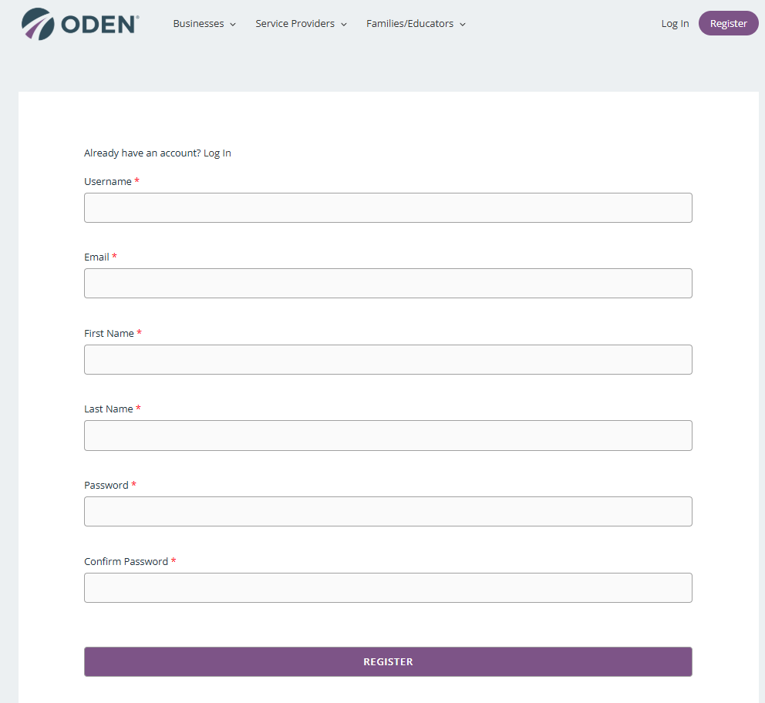
Figure 2. User Registration Form.

Step 4. After registering as a user, you will be redirected to the “User Account” page as shown in Figure 3. At this stage, no courses will be listed. The yellow notice will say “No Courses found”.

This page is where you can enter your Group Code. Note the black box and arrow shown in Figure 3 showing the Group Code button on the main menu, right hand side. Click the “Group Code” button to open the Group Code Registration page.

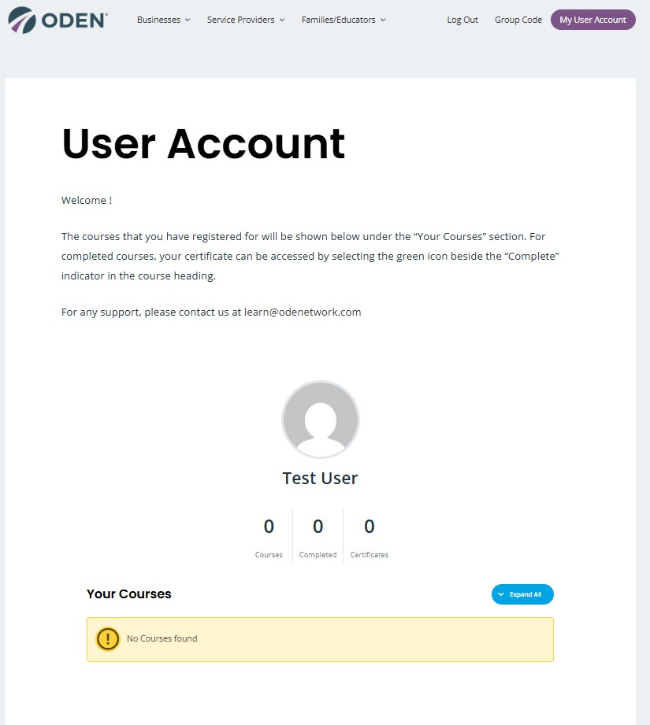

NOTE:
Figure 3. The User Account Page shown with no courses yet. Note the black box showing the Group Code button.

- If you are taking a course as part of your Professional Development, your Group Code would have come from your HR Manager, Supervisor, Team Lead, or another training contract.
- For courses and learning resources that ODEN offers at no cost, such as training for educators, youth, and families, the Group Code can be found in the course page. Browse the categories on learn.odenetwork.com to find out more about free courses.

Step 5. Click the Group Code button on the top header menu opens the Group Code Registration page. Enter the code in the box as shown on Figure 4 and press “SUBMIT”.

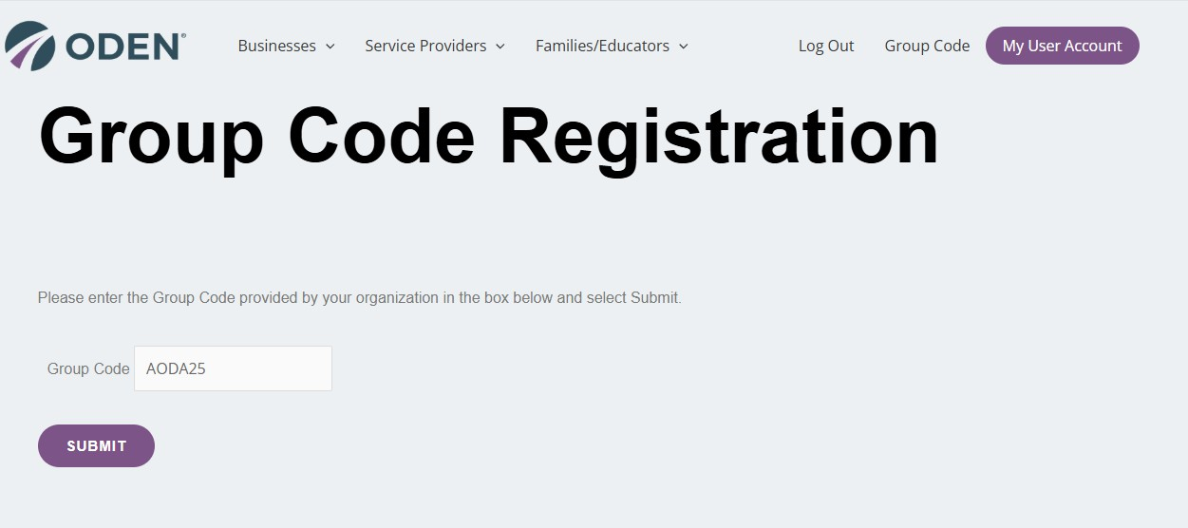
Figure 4. Example using and registering with the Group Code “AODA25”
Step 6. After you enter the group code and press the submit button, the system will return to your “User Account” page. Your assigned courses will be listed under the “Your Courses” section at the bottom of your User Account.

Figure 5 demonstrates this example, with the Beyond AODA course added to the group code
“AODA25” that was used in step 4. To add another course, repeat step 4.
Accessing Course Content

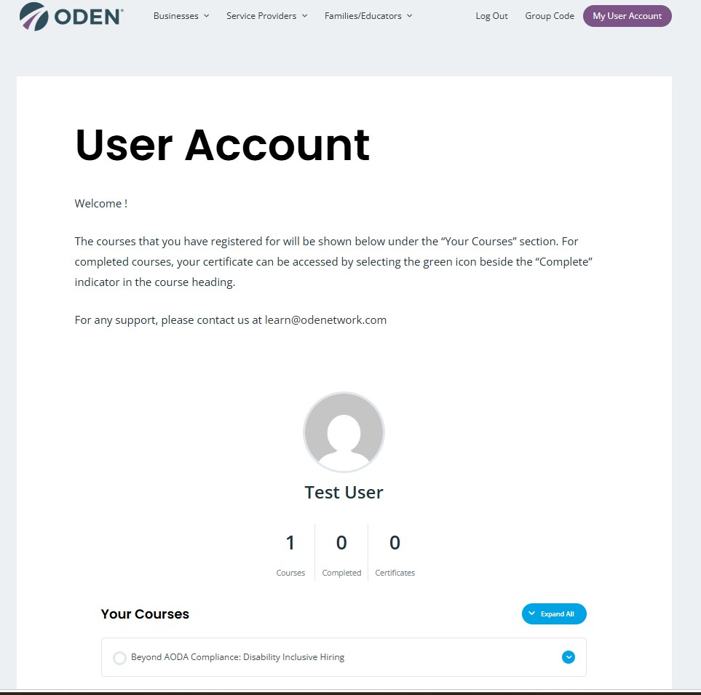
Figure 5. Example of course attached to User Account after using Group Code.

Part B: Accessing Course Content
Steps 1 through 6 explained how to create a user account and registering to courses using group codes. The next steps will support navigating the course content.
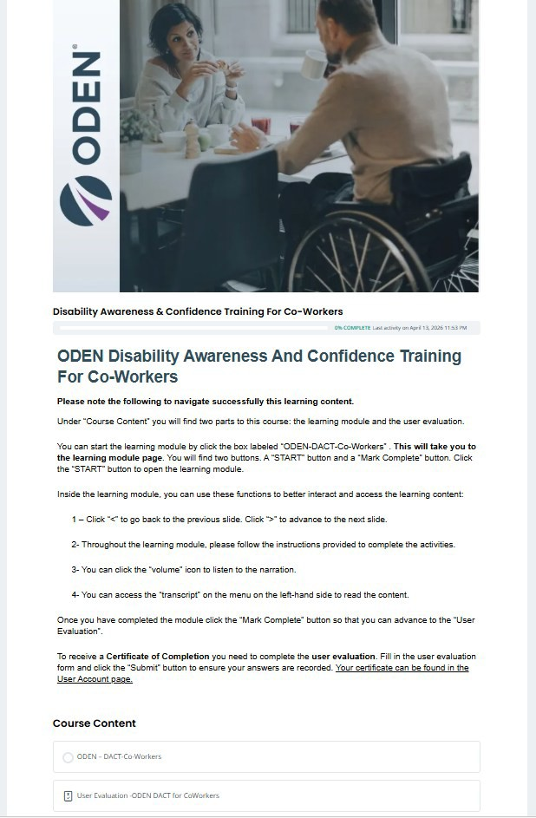
Step 7- Course content can be accessed by selecting the course in your User Account. To open the course, navigate to “Your Courses” section in your User Account and click the course name, the system will open the “Course Page”. The course page is shown in Figure 6.

A course page can have a decorative picture at the top, instructions to navigate the course, and the “Course Content” which contains: the content lesson(s) and the course evaluation. Figure 6 illustrates the general look for ODEN’s DACT for Co-Workers.

NOTE: DACT stands for Disability Awareness and Confidence Training.
Step 8- Click the name of the course lesson or learning module at the bottom of the course page. In this example, the learning module is called “ODEN-DACT-Co-Workers”.

The learning module will open as illustrated in Figure 7. You will need to click the “Start” button as shown in the black box in Figure 7 to open the window and go through the module content as shown in Figure 8.

Once you complete the learning module, or exit by clicking on the top right corner, you will need to click the green button “Mark Complete” to advance to the User Evaluation as shown in Figure 9.
Fill the evaluation and submit.

Figure 6. Course Page for ODEN’s DACT for Co-Workers Training.

NOTE: You can always access your User Account by going to the top right corner in this window- see the red box – as well as access the log out function.

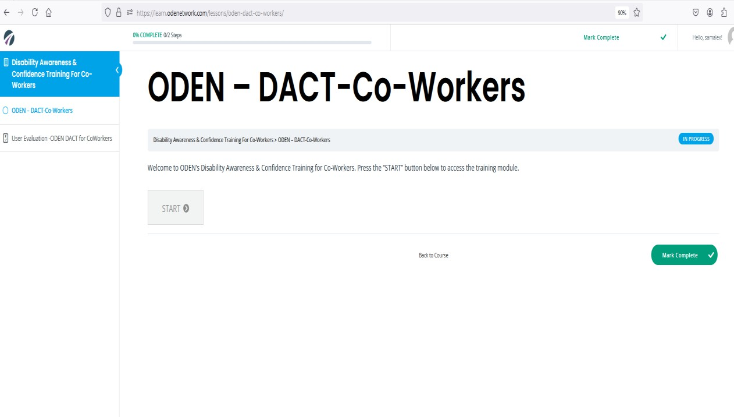
Figure 7. Window that opens to access a learning module within a course. This example shows the learning module for ODEN-DACT-Co-Workers.
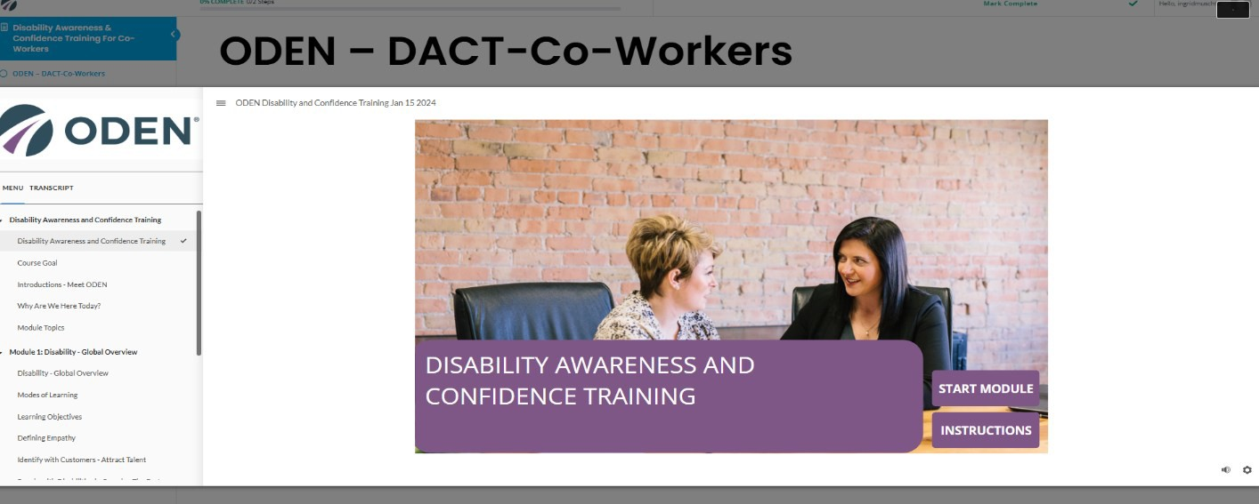
Figure 8. Learning module window. Follow the instructions in this window to access the content. The red box shows the exit button at the top right.

Figure 9. Learning module window. After completing the learning module, click the “Mark Course as Complete” -the green button – to advance to the evaluation form.

Step 9- Once you complete the User Evaluation, the system will return you to your User Account page. The Certificate of Completion can be found in the section “Your Courses” as a small green box, near the green complete button – note the black box and black arrow in Figure 10. Click on that small green box to open the PDF of your Certificate of Completion.
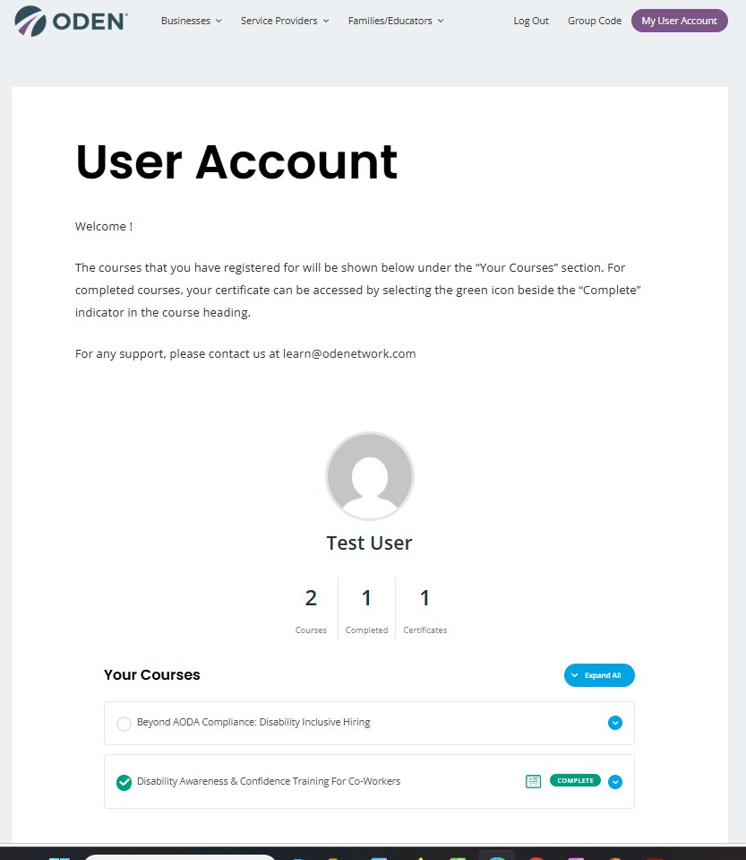
Figure 10. User Account page – how to download your Certificate of Completion.

If you require any assistance, please email us at learn@odenetwork.com.

Part C: TECHNICAL TROUBLESHOOTING
If you can not access the login page, this may be caused by a pop-up blocker. Click the red
“X” icon, in the right corner of your browser address bar, labelled “1” in the image below.
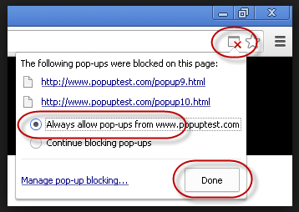
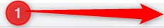
Pop-Up Blocker in Google Chrome

Click on the red X icon (Number 1) and you will see an option to allow the pop-up from ODEN’s Learn. Select “Always allow” and click Done. After you click “Done”, refresh the page to save your choice and see the pop-up page where you can login with your newly created username and password.

For more information on managing with pop-ups and how to manage exceptions, you can view this short video: https://youtu.be/YNx2xvVt9Do

